Creating and Downloading a PDF for Meet Results

STEP #1 Click onto REPORTS and then RESULTS

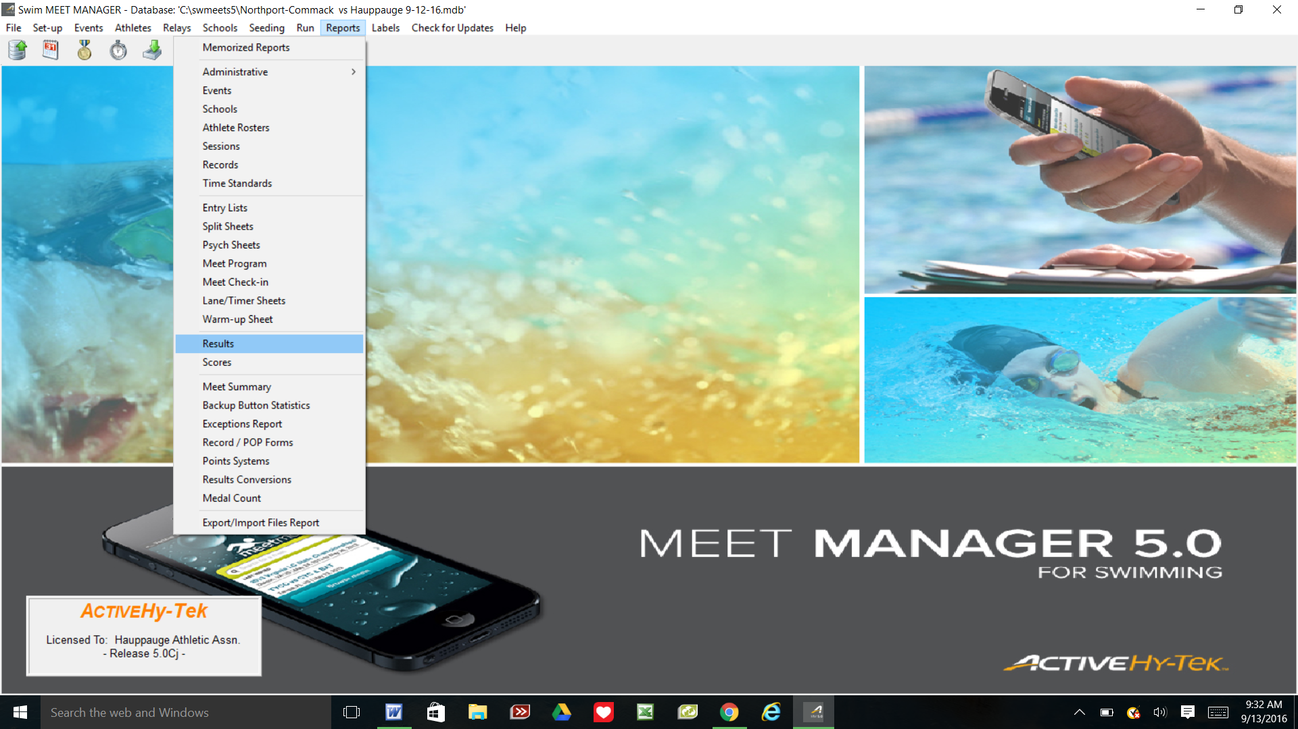

STEP #2 Click "SELECT ALL" then "CREATE REPORT"

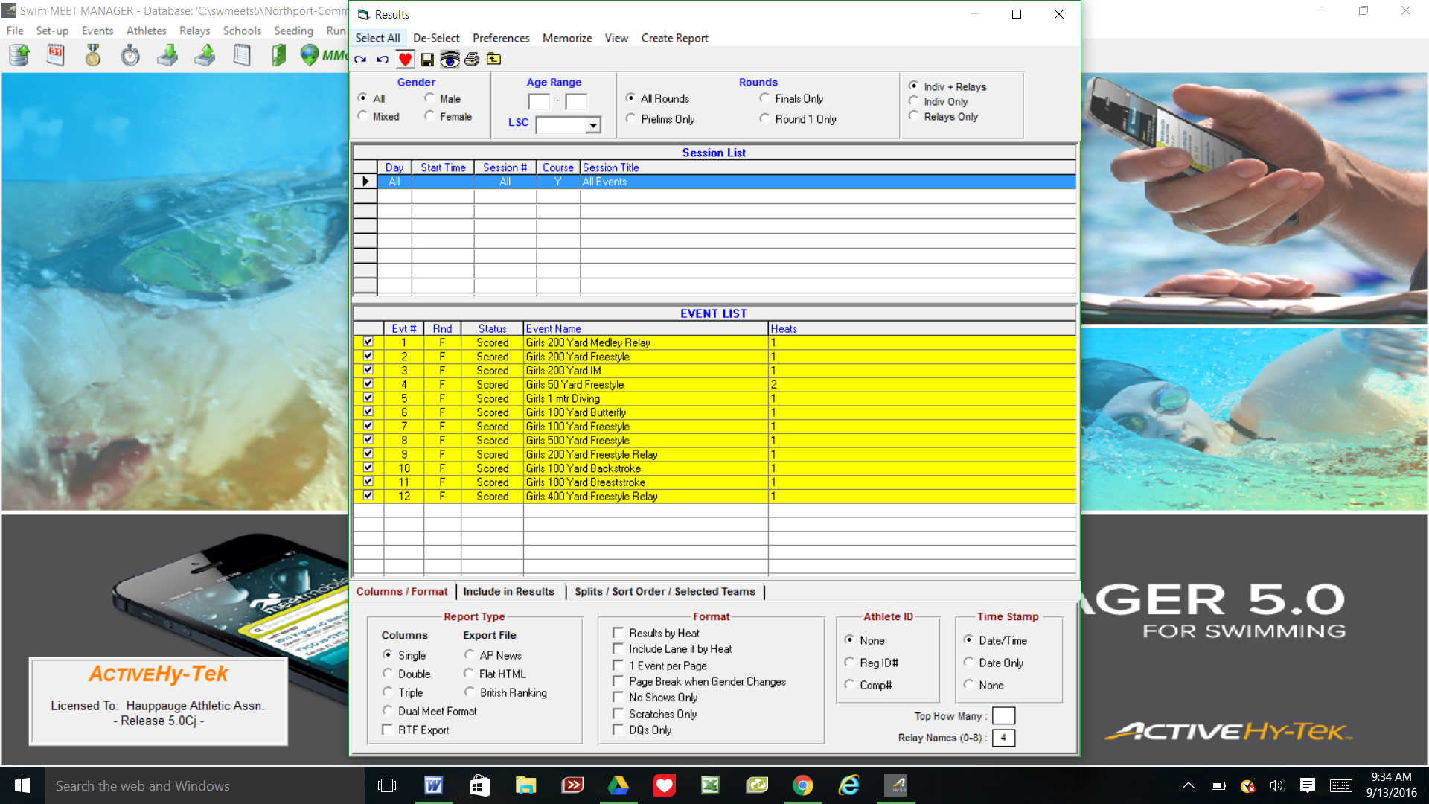

STEP #3 Click above Preview on left icon. This will create the PDF. Screen should look like this. Then click OK.

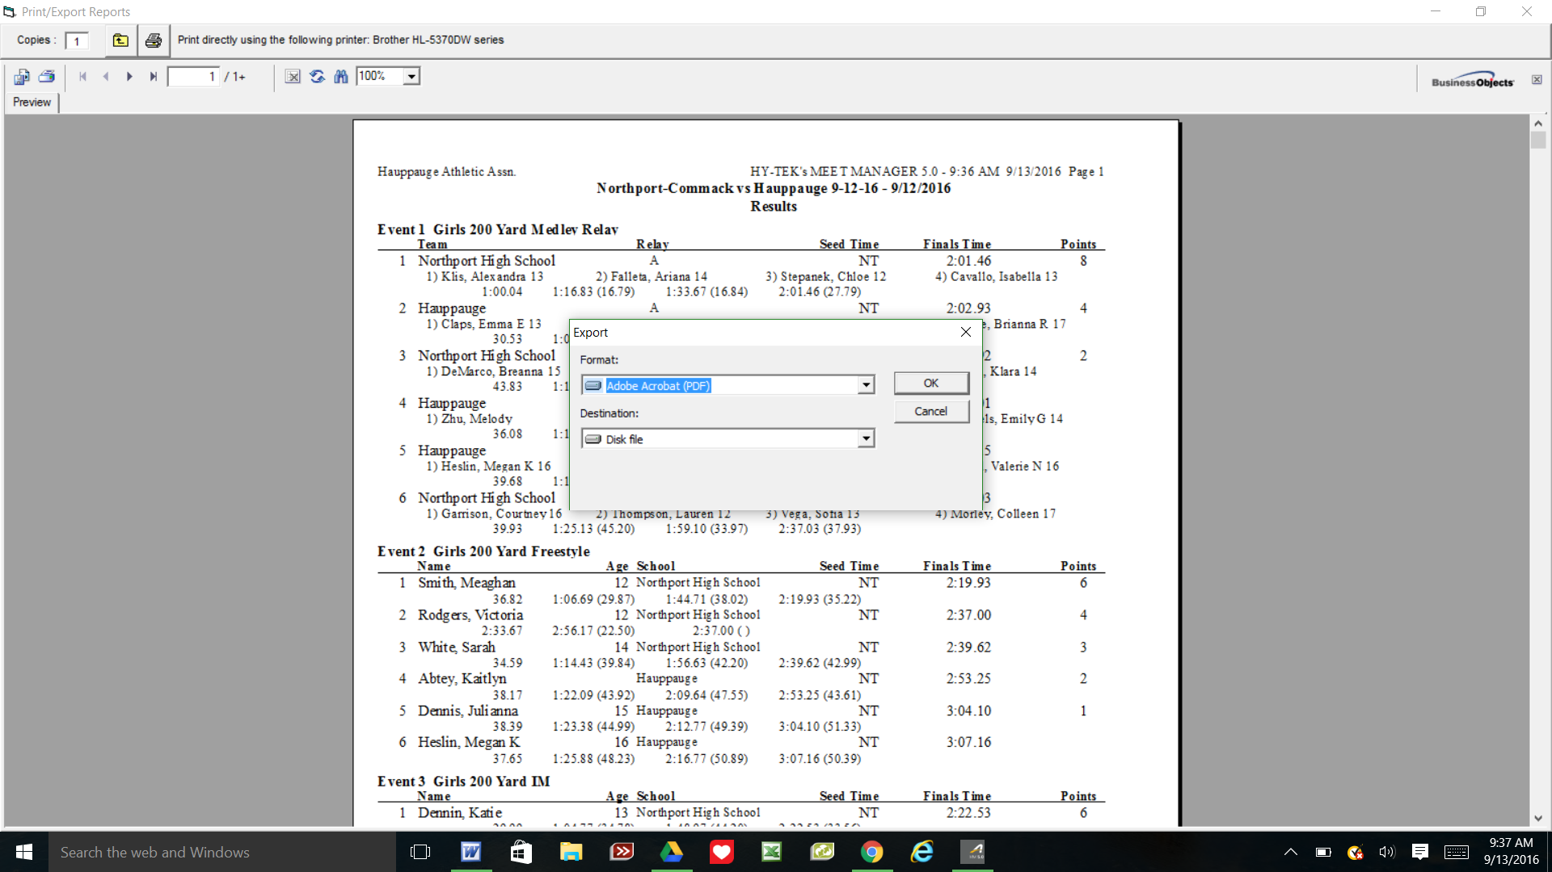

STEP #4 Export Options will be the next box to appear. Click OK.

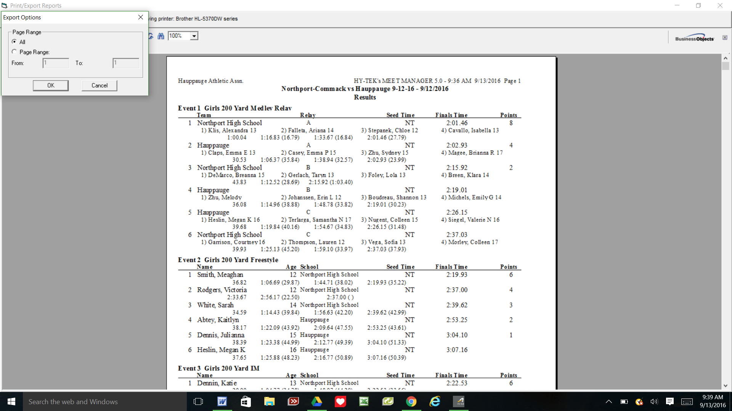

STEP #5 Name and Save the file of the Meet.

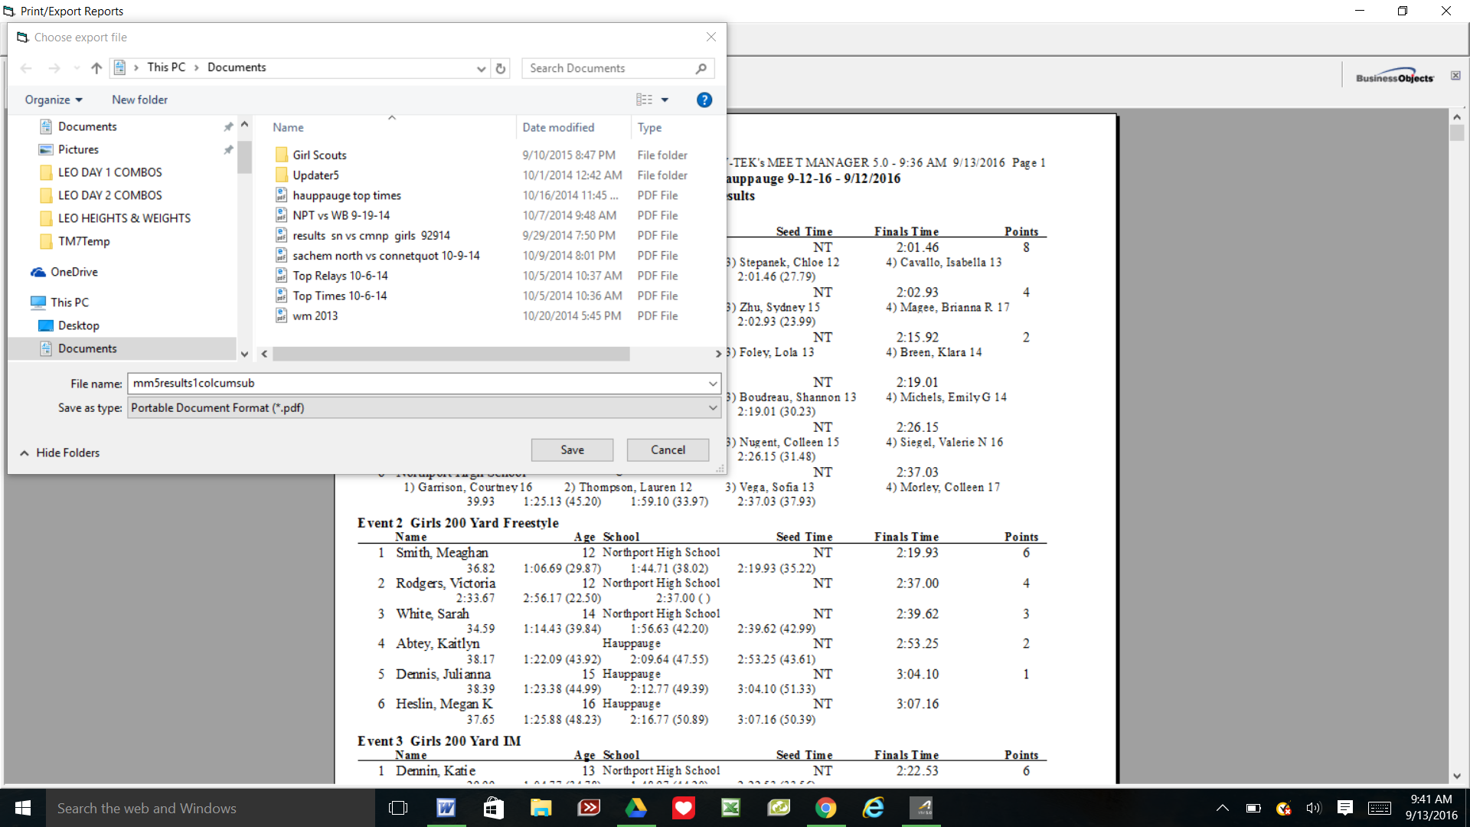

Name your file: Put the away and home teams and the date of the meet. You can use short names for schools.
Save it to you file or flash drive. Attach PDF to an email and send.

